ST 314 Practice Midterm Exam

The following questions are meant to give you sense of what the midterm exam might look like. This should not be your only source of study material! See Canvas for suggestions of other resources you can use to prepare for the exam.

## True or False: Questions 1-5

1. Under a standard normal density curve, 50% of the distribution falls below the mean.
   1. True
   2. False
2. For data that are right skewed, the mean is less than the median.
   1. True
   2. False
3. For any two events, A and B, the probability of the intersection of the two events can be found by computing the product of the probabilities of each individual event. That is, $P(A∩B)=P(A)P(B)$.
   1. True
   2. False
4. An observational study imposes treatments onto subjects or units for the purpose of measuring a response.
   1. True
   2. False
5. A confidence interval becomes less precise as the sample size, n, increases.
   1. True
   2. False

## Use the following information for questions 6-7

A  computer manufacturer has three different facilities they use to manufacture monitors for their desktop computers. From each of the facilities, the monitors are inspected for defects. The tree diagram depicts this scenario, Def = defective or Monitor has defects.

1. 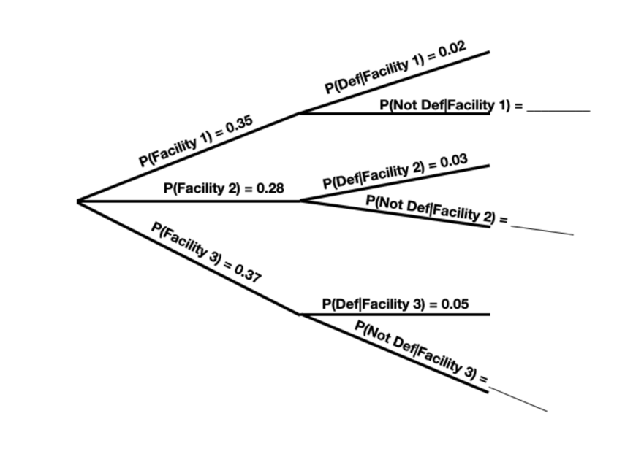Given a randomly selected monitor was manufactured at facility 2, what is the probability it has no defects?
2. Which of the following expressions correctly represents the probability that a randomly selected monitored was manufactured at facility 3 and is defective?

$0.37+0.05$

$0.37 ×0.05$

$0.37-0.95$

$0.37 ×0.95$

## Use the following information for questions 8-9

The random variable $X$ is described by the following pdf:

$$f\left(x\right)= \left\{\begin{matrix}3x^{-4}, x>1 \\ 0, otherwise \end{matrix}\right.$$

## 

1. What is the **cumulative** density function?
   1. $F\left(x\right)= 1$ for $x>1$
   2. $F\left(x\right)= -x^{-3}$ for $x>1$
   3. $F\left(x\right)= 1-x^{-3}$ for $x>1$
   4. $F\left(x\right)= 3x^{-4}$ for $x>1$
2. What is the expected value of $X$?
3. An injection molding process for making detergent bottles uses three different machines the table gives the probability mass function for the number of machines operating at any given time.

|  |  |  |  |  |
| --- | --- | --- | --- | --- |
| yi | 0 | 1 | 2 | 3 |
| p(yi) | **0.020** | **0.030** | **0.200** | **0.750** |

Which of the following expressions correctly represents that probability that two or fewer machines are running at the same time?

$P\left(Y=2\right)=0.2$

$P\left(Y≤2\right)=0.2$

$P\left(Y≤2\right)=0.2+0.03+0.02$

$P\left(Y<2\right)=0.2+0.03$

2. Which of the following statements is FALSE with respect to the standard deviation?
   1. The standard deviation is the same as the variance.
   2. The standard deviation measures the typical deviation from the mean.
   3. The standard deviation is influenced by outliers in the data.
   4. The standard deviation has the same units as the mean.
3. Chart, box and whisker chart

   Description automatically generatedThe graph below depicts total fantasy football points earned by offensive players by the end of week 7 in the 2018 NFL Season by position.

From the plot which of the following statements is FALSE?

1. The minimum value is approximately the same for all positions.
2. There are no outliers in the quarterback (QB) position.
3. The median for running backs (RB) is approximately 25 total fantasy points.
4. Based on the distributions for each position it is safe to assume the average total number of points will be the same as the median total number of points.
5. The number of cars entering a roadway at a specific exit during the morning rush hour traffic (6AM to 9AM, M-F) is a random variable modeled by a Poisson distribution, with an average of 6 cars per minute. Which of following distributions would be appropriate to model the number of cars entering the roadway?
   1. The Normal distribution
   2. The Binomial distribution
   3. The Poisson distribution
   4. The random variable cannot be modeled with any distribution.

## Use the following information for questions 14-16

The time it takes to travel between two campuses of a university in a city via shuttle bus takes an average 24 minutes. The distribution of all times is right skewed with a standard deviation of 12. Suppose a random sample of 36 transport times are recorded during a given week.

1. Which of the following describes the approximate sampling distribution of the sample mean from a random sample of size $n=36$?
   1. The sampling distribution will be approximately normal with a mean of 24 minutes and standard deviation of 12 minutes.
   2. The sampling distribution will be approximately normal with a mean of 24 minutes and standard deviation of 2 minutes.
   3. The sampling distribution will be right skewed with a mean of 24 minutes and standard deviation of 12 minutes.
   4. The sampling distribution will follow a binomial distribution with a mean of 24 minutes and standard deviation of 2 minutes.
2. Chart, line chart

   Description automatically generatedUsing the outline of the sampling distribution curve, illustrate the probability of selecting a random sample of 36 transport times with a mean travel time less than 22 minutes. Include numerical values on the tick marks representing $±1, ±2, ±3$ standard deviations above and below the center, as well as shading the region that represents the probability of interest.
3. Suppose all possible combinations of 36 observations were collected from the population. That is, all possible samples of size $n=36$ are observed. Which of the following statements regarding the sample means from these repeated samples is true?
   1. Approximately 95% of sample means will be between $24-1.96×2 = 20.08$ minutes and $24+1.96×2 = 27.92$ minutes.
   2. Approximately 95% of sample means will be between $24-1.96×12 = 0.48$ minutes and $24+1.96×12 = 47.52$ minutes.
   3. Approximately 90% of sample means will be between $24-1.96×2 = 20.08$ minutes and $24+1.96×2 = 27.92$ minutes.
   4. Approximately 90% of sample means will be between $24-1.96×12 = 0.48$ minutes and $24+1.96×12 = 47.52$ minutes.
4. The **sampling distribution** of a statistic is
   1. the probability that we obtain the statistic in repeated random samples.
   2. the probability distribution of the randomly sampled statistic.
   3. the mechanism that determines whether randomization was effective.
   4. the extent to which the sample results differ systematically from the truth.

## Use the following information for questions 18-19

A store randomly samples 603 shoppers over the course of a year and finds that 142 of them made their visit because of a coupon they received in the mail.

1. Construct the **90%** confidence interval for the proportion of shoppers that visited the store because they received a coupon in the mail. *You do not need to do any of the calculations – just set up the construction of the confidence interval.*
2. The **95%** confidence interval is (0.202, 0.269). Interpret this confidence interval in the context of the problem.